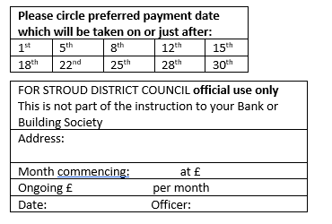Direct Debiting

*the modern way to pay*

*……………………………………………………*

|  |  |
| --- | --- |
| What is Direct Debit? | Control You - the payer - remain in total control. You can cancel the authority simply be informing your Bank or Building Society. You will, of course, be notified in advance of any changes in amounts and date(s) of payment. Should you have a query about any payment contact your Bank or Building Society.  They can make an immediate refund.  **Direct Debit is used by many organisations, including:**  • Insurance Companies • Building Societies •  • Local Authorities • Gas • Electricity •  • Telephone • Water Authorities •  • Finance Companies • Major Industrial and commercial organisations • Major societies and associations with national membership •  **and is supported by:**  • Allied Irish Banks  • Bank of England  • Bank of Ireland  • Bank of Scotland  • Barclays Bank  • Central Trustee Savings Bank  • Clydesdale Bank  • Co-operative Bank  • Coutts & Co  • Girobank  • Lloyds Bank  • HSBC  • National Westminster Bank  • Northern Bank  • The Royal Bank of Scotland  • Ulster Bank  • Several Building Societies For further information Talk to your Bank, Building Society, or Tenant Services on: (01453) 766321 |
| A simple, safe and convenient banking service which enables you to authorise your Bank or Building Society to settle your accounts as and when they fall due. |
| What can be paid by Direct Debit? |
| Rent, Council Tax, subscriptions, insurance premiums, water and telephone bills and many other household bills can often be settled in this way. More and more organisations are inviting their customers to pay their accounts by Direct Debit. |
| How does it work? |
| Payment is made automatically from your current account in accordance with your instructions to the Bank or Building Society. |
| How you benefit |
| There is no need to write out and post a cheque each time an account becomes due. Nor do you have to give fresh instructions to your Bank or Building Society if the amount varies (for example when an annual increase in local authority rents takes place). |
| Simplicity |
| All you need to do is complete an instruction addressed to your Bank or Building Society.  Your Bank or Building Society will do the rest. |
| Safety |
| No payments can be made unless you have authorised your Bank or Building Society to do so. Only organisations approved by the Banks are allowed to operate the service |

 **STROUD DISTRICT** COUNCIL